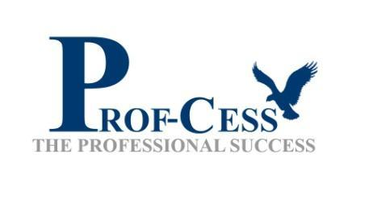

Greetings from Prof-Cess!

Here are the details of the company and internship.

Prof-Cess is a digital job platform, founded by an IIT Roorkee alumnus with a vision to minimize the gap between industries, students and institutes. Prof-Cess connects skilled students to emerging startups by providing them a perfect internship and job opportunities.

Website: <https://www.profcess.com/>

LinkedIn: <https://www.linkedin.com/company/profcess/>

Prof-Cess is **hiring interns** for the following positions:-

1. HR Executive

2. Software Developer (Preferred Language: Python)

3. Business Developer

4. UI/UX Designers

5. Social Media Marketer

6. Android Developer

7. Content Writer

**Details:-**

Work from Home

Duration-2 months

Looking forward to hearing from you.

**Job Description for each role:**

1. **HR Executive:**

* Excellent Communication skills (Verbal & Written)
* Using LinkedIn and other outbound methods for finding the candidates
* screening right candidate for the right job
* Operating Ms Word and Ms Excel

1. **Software Developer**

* Candidates must know the basics of Python.
* Participation in the internship program is open for all Technical students.
* Placements are made based on the compatibility of the student’s interests and academic background and the needs.
* Be enrolled in a graduate or post graduate school program (Second University Degree or equivalent, or higher).
* Students must have a resume prepared.

1. **Business Developer**

* Familiarizing yourself with all products and services offered by our company.
* Procuring new clients through emails and tele-based selling.
* Attending networking activities and portals to research and connect with prospective clients.
* Maintaining meaningful relationships with existing clients to ensure that they are retained.
* Suggesting upgrades or added products and services that may be of interest to clients.
* Negotiating with clients to secure the most attractive prices.

1. **UI/UX Designer**

* plan and implement new designs
* Optimize existing user interface designs
* Test for intuitively and experience
* Develop technical and business requirements and always strive to deliver intuitive and user-centered solutions
* Combine creativity with an awareness of the design elements
* Create prototypes for new product ideas
* Test new ideas before implementing
* Conduct an ongoing user research
* A portfolio of professional UI/UX design work for both web and mobile platforms.
* Working knowledge of the following technologies:- Adobe xd, Adobe photoshop, Adobe Illustrator, figma,
* A team player but can work independently too.
* Multi-tasking and time-management skills, with the ability to prioritize tasks.

1. **Social Media Marketer**

* Manage the company’s social media accounts and posts content.
* Brainstorms campaign ideas and create posters.
* Monitor various social media platforms such as Facebook, Instagram, and Twitter.
* Work alongside the team to create a plan for social media strategies.
* Assist in the growth of the brand by raising awareness through various social media platforms
* Aid in the daily aspects of promoting the businesses campaigns
* Interact with followers and potential customers by communicating and answering questions through the company's social pages

1. **Content Writer**

* Research industry-related topics (combining online sources, interviews and studies).
* Write clear marketing copy to promote our products/services.
* Prepare well-structured drafts using Content Management Systems.
* Proofread and edit blog posts before publication.
* Submit work to editors for input and approval.
* Coordinate with marketing and design teams to illustrate articles.
* Conduct simple keyword research and use SEO guidelines to increase web traffic.
* Promote content on social media.
* Identify customers’ needs and gaps in our content and recommend new topics.
* Ensure all-around consistency (style, fonts, images and tone).
* Update website content as needed